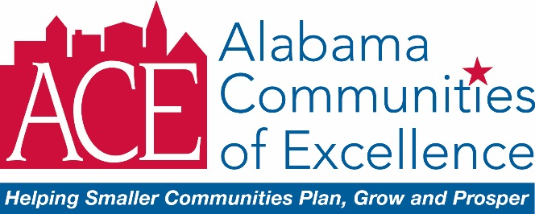

**2017 ACE Star Award Nomination Form** j0091315

**Deadline to Submit Nominations for 2017 ACE Star Awards: is THURSDAY, June 15, 2017!!!!**

**Submit to:** [**marthawhitson@gmail.com**](mailto:marthawhitson@gmail.com)

NOMINATION Made by (YOUR Name): **Click here to enter text.**

Name of Nominee: **Click here to enter text.**

Title of Nominee: **Click here to enter text.**

ACE Community/Partner Organization: **Click here to enter text.**

**Please click in the text box below to provide details of why your nominee is deserving of this award:**

**Click here to enter text.**

**Choose ONE of the following categories for your nomination**: (as described in the Nomination Instructions)

Outstanding ACE Mayor

Outstanding ACE Ambassador

Outstanding ACE Local Coordinator

Exceptional ACE Leadership

Outstanding ACE Volunteer

**The 2017 ACE Star Award recipients will be recognized at the  
ACE Community Annual Reunion held Friday, July 14, 2017 at the Alabama Power Company - Clanton Conference Center located at  
2030 7th Street South, Clanton, AL 35045**

**Registration for the Reunion is available on the ACE website: The deadline to register is 6/30/17**

**CLICK the link below to REGISTER**

<http://www.alabamacommunitiesofexcellence.org/event/ace-2017-community-reunion/>

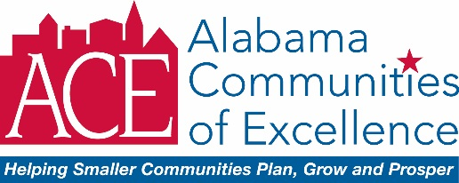

j0091315 **Instructions for 2017 ACE Star Award!!**

The **ACE Star Award** recognizes individuals considered to be the “shining stars”

of the ACE Program and have performed above and beyond the call of duty—

ACE Partners/Associates Council Members, ACE Community Participants,

and ACE Volunteers are eligible for this award.

**HOW TO SUBMIT NOMINATIONS FOR THE 2017 ACE STAR AWARDS**

Nominations may be made by **any** ACE Partner/Associates Council Member or ACE Community Participant

* Complete the Nomination Form and e-mail to [marthawhitson@gmail.com](mailto:marthawhitson@gmail.com). Describe why the individual is deserving of the award – **nominations must be received by 6/15/17.**
* Nominations should identify an award from one of the five categories below:

**Outstanding ACE Mayor**Recognizes a Mayor that has performed above and beyond the call of duty while participating in the ACE program

**Outstanding ACE Ambassador** Recognizes an ACE Captain or Mentor (ACE Partner, Associates Council Member) that has performed above and beyond the call of duty while participating in the ACE program

**Outstanding ACE Local Coordinator** Recognizes a Local Coordinator (community participant appointed Local Coordinator by Mayor) that has performed above and beyond the call of duty while participating in the ACE program

**Exceptional ACE Leadership** Recognizes an individual that has provided exceptional leadership for the ACE program (can be ACE Partner/Associates Council Member, ACE Community Participant, or ACE Volunteer)

**Outstanding ACE Volunteer** Recognizes an individual that has provided outstanding volunteer service to the ACE program (can be ACE Partner/Associates Council Member, ACE Community Participant, or ACE Volunteer)

**Submit the 2017 ACE Star Award Nomination Form by Thursday, June 15, 2017**

**Submit to:** [**marthawhitson@gmail.com**](mailto:marthawhitson@gmail.com)

**Past Recipients of the ACE Star Award** j0091315

**Robert Avant** – 2015 Outstanding ACE Local Coordinator **Carrie Banks –** 2016 Outstanding ACE Volunteer

**Carolyn Bern** – 2009 Outstanding ACE Volunteer

**Anna Berry** – 2006 Outstanding ACE Mayor (Heflin)

**Lucas Blankenship** – 2015 Outstanding ACE Team Captain  
**Diane Burnett** – 2014 Outstanding ACE Team Captain

**Pat Butler** – 2005 Outstanding ACE Team Captain

**Hollie Cost** – 2014 Outstanding Mayor (Montevallo)

**Bill Curtis** – 2014 Exceptional ACE Leadership

**Terri Daulton** – 2007 Outstanding ACE Local Coordinator

**Sheldon Day** – 2009 Outstanding ACE Mayor (Thomasville)

**Sondra Dunaway** – 2007 Outstanding ACE Volunteer

**Mike Easterwood** – 2009 Outstanding ACE Volunteer

**Mike Easterwood** – 2016 Exceptional ACE Leadership

**Larry Fluker** – 2008 Outstanding ACE Mayor (Evergreen)

**Glen Haab** –2008 Outstanding ACE Team Captain

**Pat Hall** – 2014 Outstanding ACE Local Coordinator

**Daryl Harper** –2008 Outstanding ACE Local Coordinator

**Bob Howard** – 2005 Exceptional ACE Leadership

**Ted Jennings** – 2009 Outstanding ACE Mayor (Brewton)

**Yolanda Johnson** – 2015 Outstanding ACE Volunteer **Herman Lehman,** 2016 Outstanding ACE Local Coordinator **William Lineberry** – 2007 Outstanding ACE Volunteer

**Richard Long** – 2007 Outstanding ACE Mayor (Jackson)

**Yancey Lovelace –** 2016 Outstanding ACE Mayor (Brewton)

**Ben McCrory** – 2012 Outstanding ACE Mayor (Montevallo)

**Toni McKelvey** – 2013 Outstanding ACE Local Coordinator

**Arturo Menefee** –2008 Outstanding ACE Volunteer

**Nisa Miranda** –2008 Exceptional ACE Leadership

**Ray Nelson** – 2013 Outstanding Mayor (Fayette) **Tammy Perry** – 2013 Outstanding Volunteer

**Larry Pinkerton** – 2007 Outstanding ACE Local Coordinator

**Milla Sachs** – 2006 Outstanding ACE Volunteer

**Phil Scharre** – 2006 Outstanding ACE Team Captain

**Phil Segraves** – 2005 Outstanding ACE Mayor (Guin)

**Mary Shell** – 2005 Outstanding ACE Team Captain  
**Mary Shell** – 2015 Exceptional ACE Leadership

**Lamar Smith** – 2007 Outstanding ACE Team Captain

**Sandy Smith** – 2005 Outstanding ACE Local Coordinator

**Shane Smith** – 2014 Outstanding ACE Volunteer

**Ephraim Stockdale** – 2009 Outstanding ACE Volunteer

**Ken Sunseri** – 2005 Outstanding ACE Volunteer

**Ken Sunseri** – 2015 Outstanding ACE Mayor (Haleyville)

**Linda Swann** – 2013 Exceptional ACE Leadership

**Sanquenetta Thompson** – 2012 Outstanding ACE Local Coordinator

**Tim Towns** – 2006 Outstanding ACE Volunteer

**Nathan Willingham** – 2016 Outstanding ACE Team Captain

j0091315

**CLICK the link below to REGISTER for the Community Reunion**

<http://www.alabamacommunitiesofexcellence.org/event/ace-2017-community-reunion/>